Mirth安装步骤

1.安装JDK，推荐安装OpenJDK11 64位OpenJDK11U-jdk_x64_windows_hotspot_11.0.10_9.msi,下载URL地址:https://github.com/AdoptOpenJDK/openjdk11-binaries/releases/download/jdk-11.0.10+9/OpenJDK11U-jdk_x64_windows_hotspot_11.0.10_9.msi
安装过程截图如下：
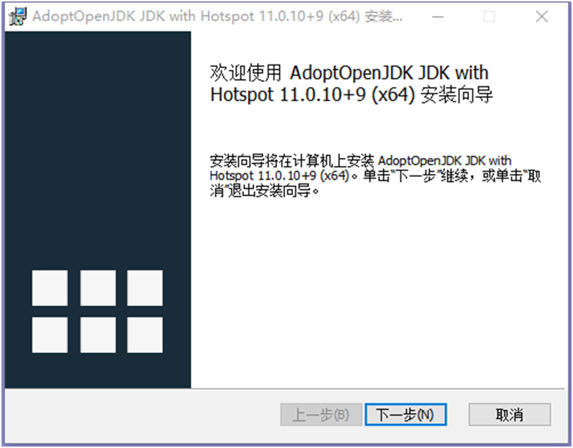

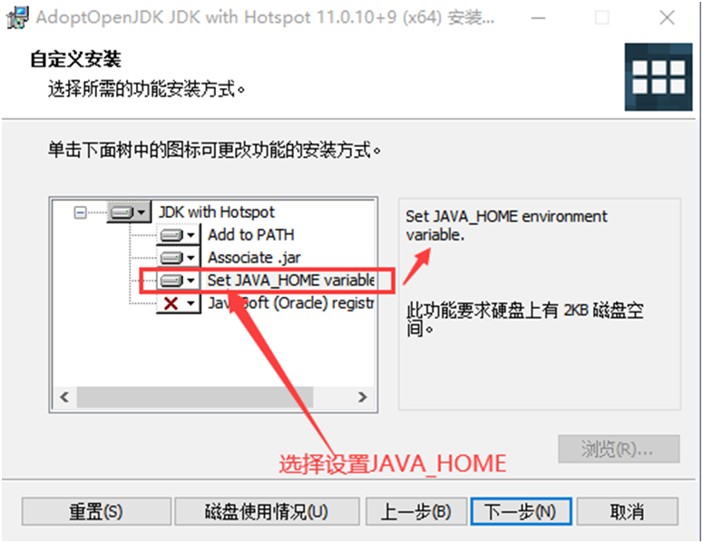

(选择设置JAVA_HOME)
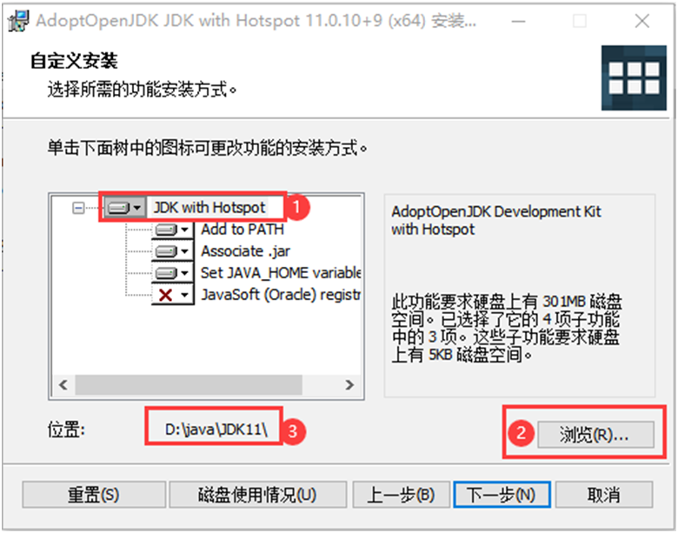

(选择安装目录为非空格目录D:\java\JDK11)

openjdk11的安装后默认是没有jre的:

【解决方法】：
在使用bin\jlink.exe --module-path jmods --add-modules java.desktop --output jre命令手动生成jre
【具体操作】：

Cmd定位到openjdk的安装目录D:\java\jdk11；cmd执行bin\jlink.exe --module-path jmods --add-modules java.desktop --output jre 命令，如下图：

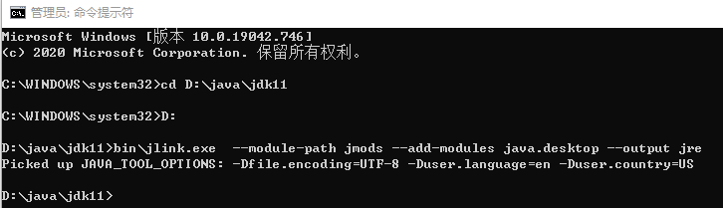

生成的JRE目录为：D:\java\jdk11\jre

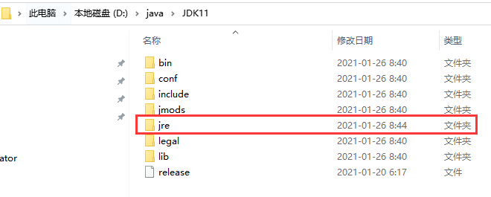

安装JDK后，同时必须配置win10的系统环境变量【示例如下】：

JAVA_HOME：D:\java\JDK11

EXE4J_JAVA_HOME：D:\java\JDK11

JAVA_TOOL_OPTIONS：Dfile.encoding=UTF-8 -Duser.language=en -Duser.country=US

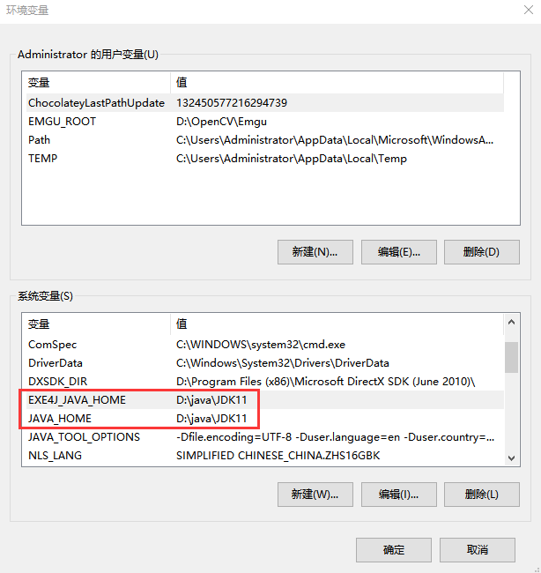

系统环境变量path把%JAVA_HOME%\jre\bin添加进去：

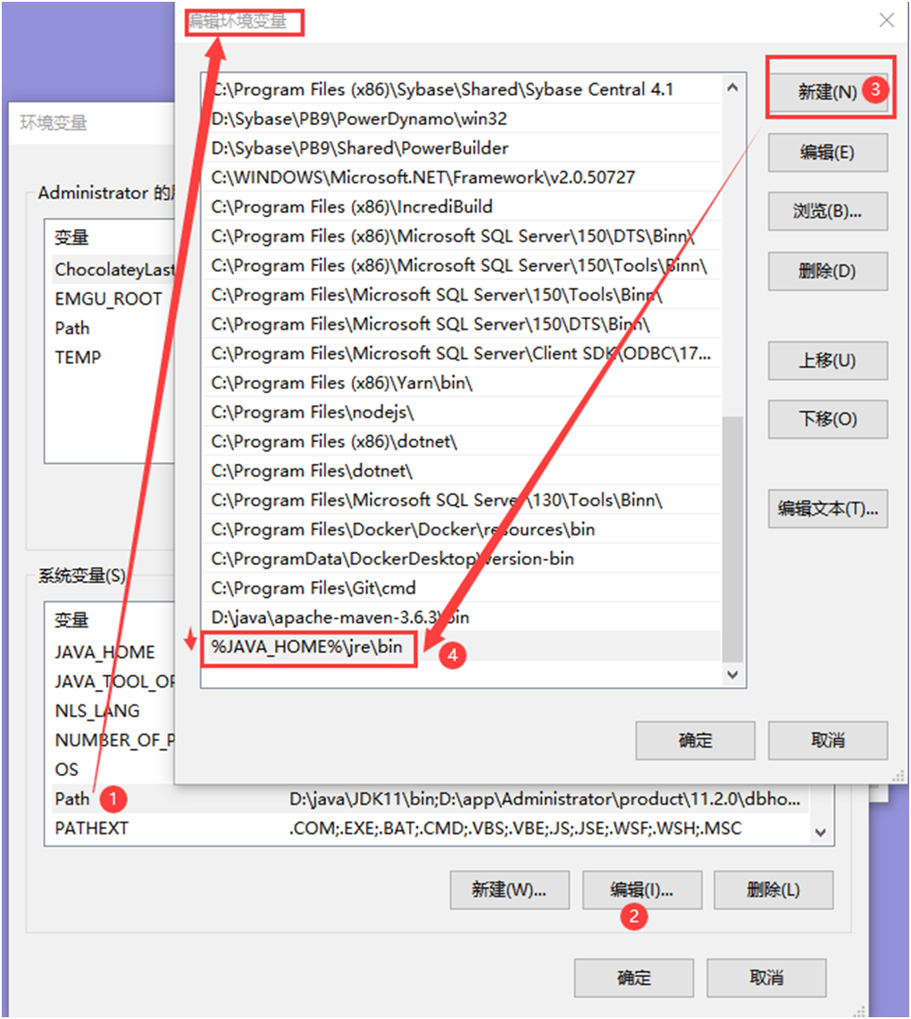

OpenJDK11安装特别说明：首先安装目录不能使用默认目录，必须是手动选择安装到非空格非中文的目录；然后配置JAVA_HOME系统变量，如上图所示。经过大量测试，如果JDK安装在默认的有空格目录，web service channel信道会报错，用不了，报错截图如下：

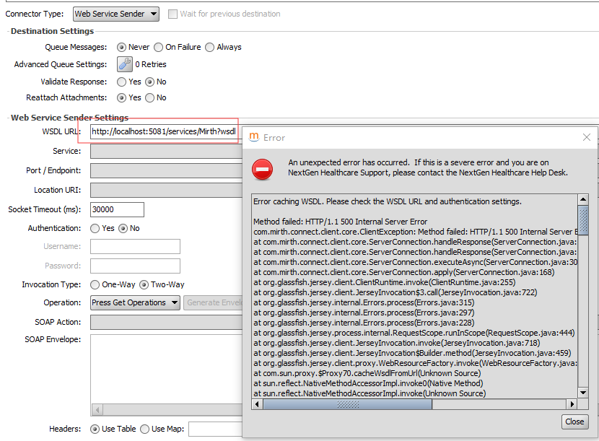

特别提示：改变环境变量，Mirth Connect管理界面正常显示不再有乱码；但信道描述和日志的中文显示会乱码；但接收和发送中文不受影响。故这样改系统环境变量后再使用 mirth 时，建立信道写信道相关描述或日志请用英文。

2.下载 apache-maven,推荐apache-maven-3.6.3版本,下载URL地址：https://maven.apache.org/download.cgi
设置系统环境变量：PATH
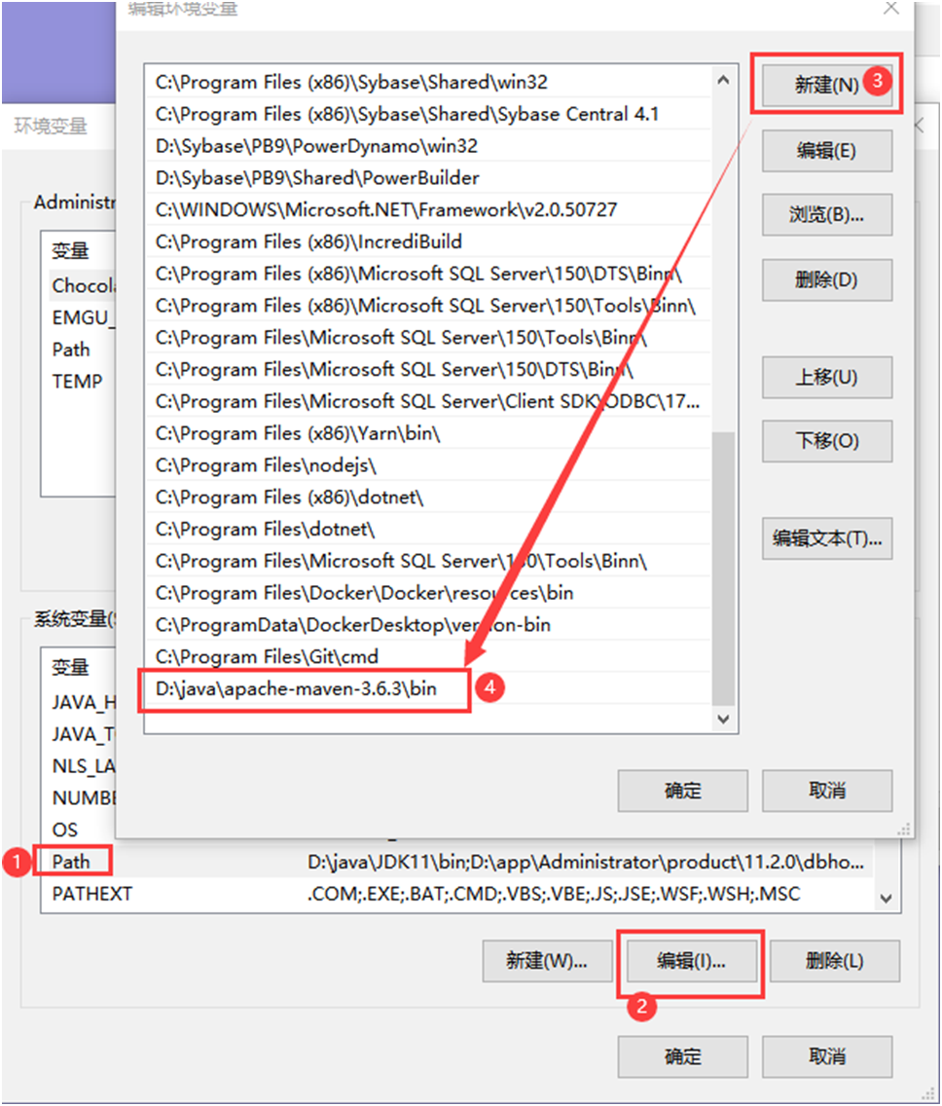

装好后在命令行cmd验证: mvn -v

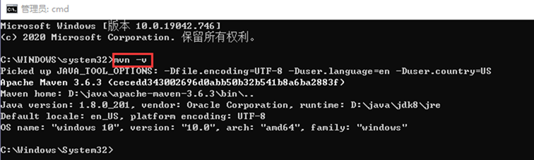

解决Maven中央仓库repo.maven.apache.org下载慢问题：
编辑D:\java\apache-maven-3.6.3\conf目录下setting.xml文件，加入阿里云的源：
<mirrors>
<!-- 阿里云仓库 -->
<mirror>
<id>alimaven</id>
<mirrorOf>central</mirrorOf>
<name>aliyun maven</name>
<url>https://maven.aliyun.com/nexus/content/repositories/central/</url>
</mirror>
<mirror>
<id>nexus-aliyun</id>
<mirrorOf>central</mirrorOf>
<name>Nexus aliyun</name>
<url>http://maven.aliyun.com/nexus/content/groups/public</url>
</mirror>
</mirrors>

3.安装Mirth，推荐安装3.10.1 64 位，版本mirthconnect-3.10.1.b280-windows-x64.exe，安装说明如下：

很不幸，当前3.10.1使用AdoptOpenJDK安装失败，提示如下：

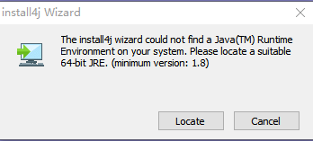

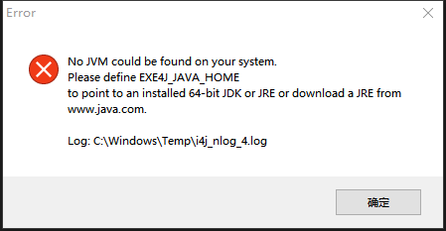

正常应该如下截图所示：
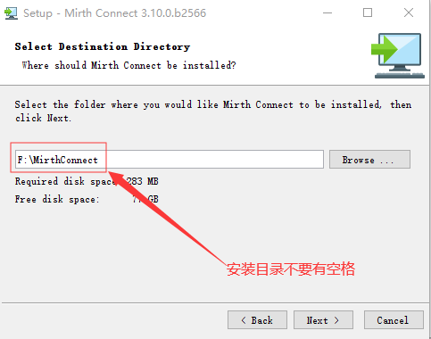

（图1，安装目录不要带有空格）
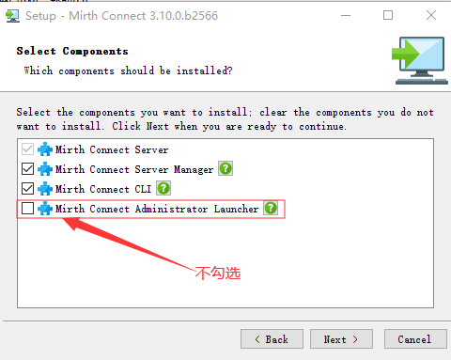

（图2，不勾选安装Administrator Launcher）
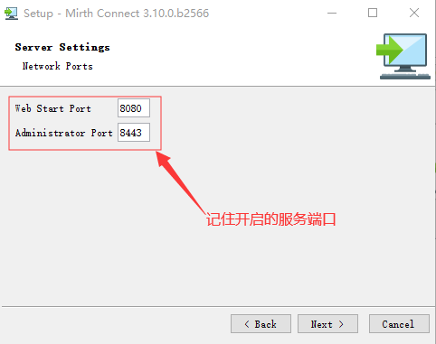

（图3，启动URL地址 https://localhost:8443 ）

4.安装客户端启动工具，推荐安装1.1.0 64 位，版本mirth-administrator-launcher-1.1.0-windows-x64.exe，安装说明如下：

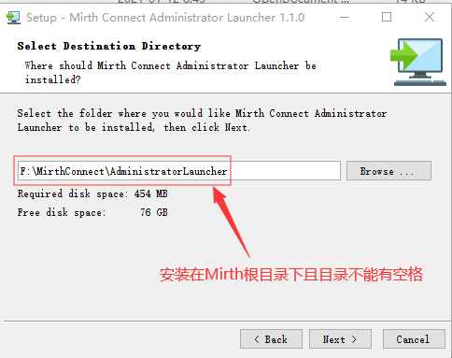

（图4，安装在第3步的根目录下且目录不能有空格）

5.安装FHIR信道扩展，推荐版本fhir-3.10.1.b286.zip；安装步骤，解压fhir-3.10.1.b286.zip后，拷贝解压后的fhir整个目录到mirth服务插件目录F:\MirthConnect\extensions中，如图所示：

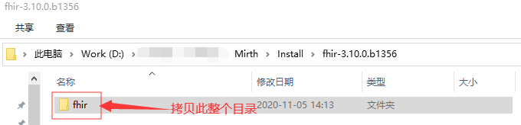

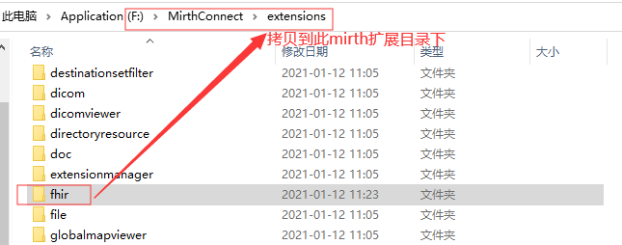

（图6，解压FHIR扩展并拷贝到mirth服务的扩展extensions根目录）

6.启动Mirth服务；然后以管理员模式启动F:\MirthConnect\AdministratorLauncher目录中的mirth administrator launcher程序launcher.exe，如图所示：

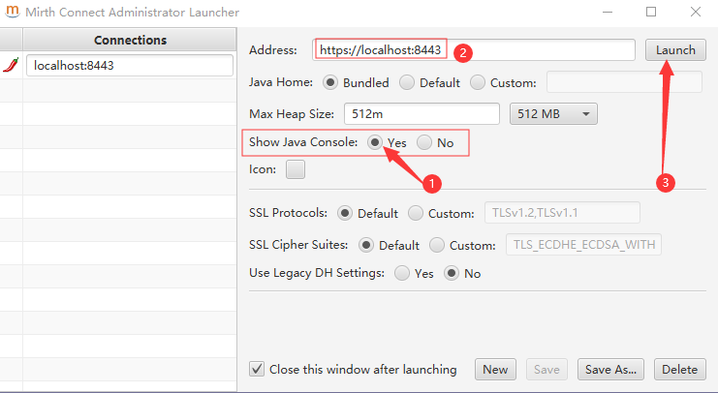

特别说明：
导入FHIR部署实例：
https://github.com/Fdawgs/ydh-fhir-listeners

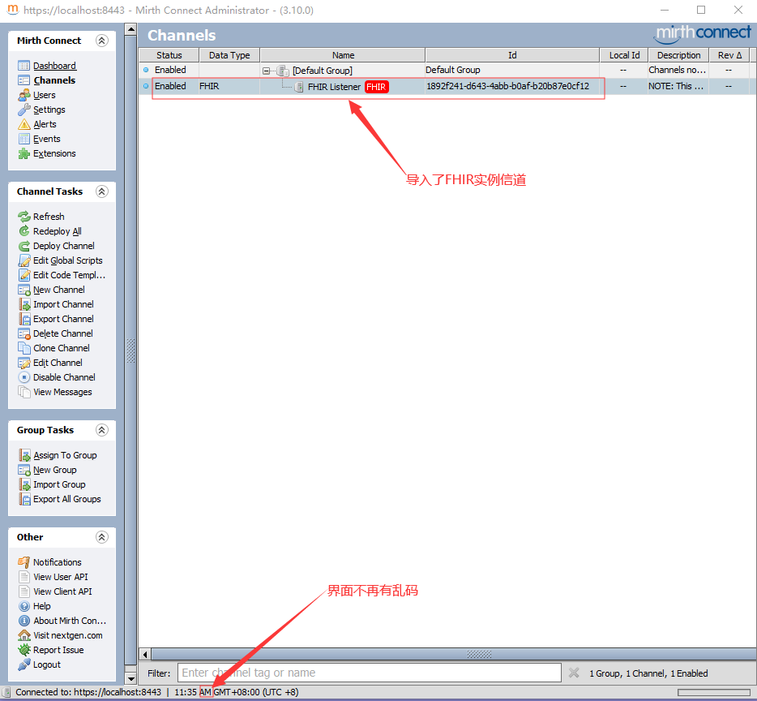

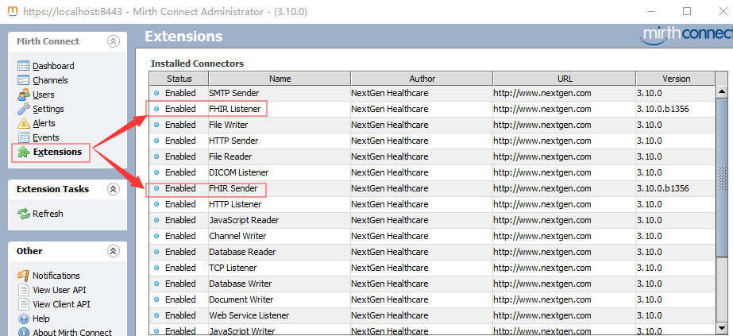

（图8，扩展视图中可见FHIR扩展已经导入且启用）

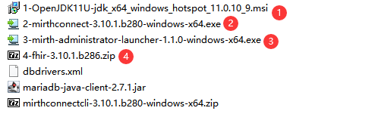

（图9，Mirth完整安装包）

MIRTH CONNECT README

Contents
==================================================

1. General Information
2. Installation and Upgrade
3. Starting Mirth Connect
4. Running Mirth Connect in Java 9 or greater
5. More Information

1. General Information
==================================================

Mirth Connect is an open source health care integration engine. By supporting numerous standards (like HL7, EDI/X12, XML, NCPDP, DICOM, and Delimited Text) and protocols (like TCP/LLP, HTTP, JDBC, and File/FTP/SFTP), Mirth Connect allows for the filtering, transformation, and routing of messages between disparate systems to allow them to share data.

2. Installation and Upgrade
==================================================

Mirth Connect installers are available for individual operating systems (EXE for Windows, RPM and SH for Linux, and DMG for Mac OS X). Pre-packaged distributions are also available for individual operating systems (ZIP for Windows, TAR.GZ for Linux, and TAR.GZ for Mac OS X). The installer allows you to automatically upgrade previous Mirth Connect installations (starting with version 1.5).

Mirth Connect installers also come with the option to install and start a service which will run the background. You also have the option of installing and running the Mirth Connect Server Manager, which allows you to start and stop the service on some operating systems, change Mirth Connect properties and backend database settings, and view the server logs.

An optional Mirth Connect Command Line Interface can be installed, allowing you to connect to a running Mirth Connect Server using a command line. This tool is useful for performing or scripting server tasks without opening the Mirth Connect Administrator.

After the installation, the Mirth Connect directory layout will look as follows:

/appdata/mirthdb: The embedded database (Do NOT delete if you specify Derby as your database). This will be created when the Mirth Connect Server is started. The path for appdata is defined by the dir.appdata property in mirth.properties.
/cli-lib: Libraries for the Mirth Connect Command Line Interface (if installed)
/client-lib: Libraries for the Mirth Connect Administrator
/conf: Configuration files
/custom-lib: Place your custom user libraries here. These libraries will be loaded on the Mirth Connect Server classpath when it is started, making them accessible to channel scripts.
/docs: This document and a copy of the Mirth Connect license
/docs/javadocs: Generated javadocs for the installed version of Mirth Connect. These documents are also available when the server is running at http://[server address]:8080/javadocs/ (i.e. http://localhost:8080/javadocs/).
/extensions: Libraries and meta data for Plug-ins and Connectors
/logs: Default location for logs generated by Mirth Connect and its sub-components
/manager-lib: Libraries for the Mirth Connect Server Manager (if installed)
/public_html: Directory exposed by the embedded web server
/server-lib: Mirth Connect server libraries
/webapps: Directory exposed by the embedded web server to host webapps

3. Starting Mirth Connect
==================================================

Once Mirth Connect has been installed, there are several ways to connect to launch the Mirth Connect Administrator. On a Windows installation, there is a Mirth Connect Administrator item in the Start Menu which launches the application directly.

If the option is not available, you can connect to the Mirth Connect Administrator launch page which by default should be available at http://[server address]:8080 (i.e. http://localhost:8080). Clicking the Launch Mirth Connect Administrator button will connect you to the server which will be listening on https://[server address]:8443 (i.e. https://localhost:8443). If running a new installation, the default username and password for the login screen is admin and admin. This should be changed immediately for security purposes.

If you are launching the administrator for the first time, you will notice that the libraries for the Mirth Connect Administrator will be loaded. This feature allows you run the Administrator from any remote Mirth Connect server without having to download and install a separate client.

You may also notice a security warning when starting the administrator (dialog box depends on browser being used). This is normal and you should click Run to continue launching the administrator.

4. Running Mirth Connect in Java 9 or greater
==================================================

In order to run Mirth Connect in Java 9 or greater, copy the options from /docs/mcservice-java9+.vmoptions and append them to either mcserver.vmoptions or mcservice.vmoptions, depending on your deployment. Then restart Mirth Connect.

To run the Mirth Connect Command Line Interface, create a new file named mccommand.vmoptions in the Mirth Connect root directory. Copy all of the options from /docs/mcservice-java9+.vmoptions into mccommand.vmoptions and save before launching the Command Line Interface.

5. More Information
==================================================

You can find the latest Mirth Connect release information, documentation, and more at: https://www.nextgen.com/products-and-services/integration-engine

Join the Mirth Connect Community at: http://www.mirthcorp.com/community/registration

